PocketMenu non-visual menus for touch screen devices

【Summary】：

We introduced PocketMenu, which is optimized for non-visual, in-pocket interaction with menus on touchscreen handheld devices. Interact with tactile functions by arranging menu items along the boundaries of the touch screen. Additional haptic feedback and voice allow non-visual recognition of individual menu items.

【PocketMenu】：

**Layout：**

As a solution, PocketMenu (see Fig. 2) combines previous approaches into a new concept. The menu items are laid out along the screen’s border.

**Browse Items：**

To browse the menu, the user slides her/his finger along the screen’s border.

**Cancel Browsing：**

Browsing the menu can be aborted by simply releasing the finger.

**Select and Alter：**

The PocketMenu offers two kinds of items: button-like items that trigger associated actions (e.g. Play or Pause) and slider-like items that allow to continuously ad-just a value (e.g. Volume). The selection of button items is inspired by the classic PieMenu [2]: by swiping the finger towards the middle of the screen the associated action is exe-cuted. A short tactile pulse (100ms) confirms that the button item has been ’pressed’. Slider items are selected in a similar way. The associated value can be adjusted by swiping more or less far away from the menu border before lifting the fin-ger. A series of short tactile pulses (< 10ms) issued when moving the finger indicate that the associated value is altered.

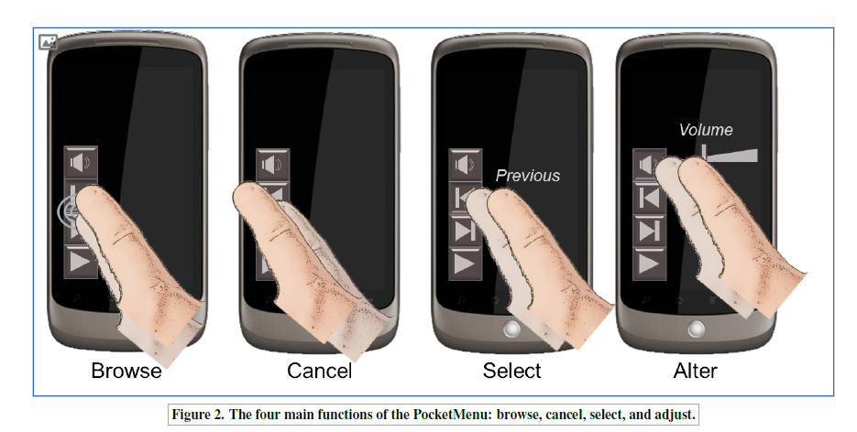

【Important Reference】:

Bonner, M. N., Brudvik, J. T., Abowd, G. D., and Edwards, W. K. No-look notes: Accessible eyes-free multi-touch text entry. In Pervasive (2010).

Yatani, K., and Truong, K. N. Semfeel: a user interface with semantic tactile feedback for mobile touch-screen devices. In Proc. UIST (2009).